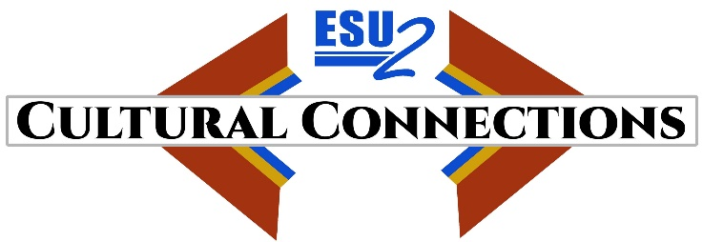

Cultural Connections August 2022 Update

As Cultural Connections, Educational Service Unit 2’s US Dept. of Education’s Demonstration Grants for Indian Children and Youth Program’s Accessing Choices in Education begins the 2022-23 schoolyear. ESU 2 and our school district partners Bancroft-Rosalie, Homer, Lyons-Decatur, Pender, Tekamah-Herman, Emerson-Hubbard, and Oakland-Craig continue to provide culturally relevant student opportunities, supports, and educational choice for Native American students and their families.

Project Director Dr. Chris Stogdill, the former middle school principal at Blair CSD continues to work closely with the schools and partners and conducts site visits at each participating district.

Summer 2022 highlights include:

- June 4th kickoff event at the Neihardt Center had 27 attendees. At the event 22 students learned about the upcoming workshop and instructors were present to answer questions. Students tasted traditional dishes prepared by Chef Anthony Warrior and the Many Moccasins Dance Troupe performed.

- Summer 2022 Cultural Connections 4-day workshop at the Neihardt Center in Bancroft was conducted on June 28 – July 1. 47 students from 5 participating districts attended. Instructors taught sessions on Native American culture and traditions. Hands-on activities provided students an opportunity to create projects and learn traditional methods and games – including lacrosse. Transportation and meals were provided. All projects went home with the students on the last day of the workshop.

A two minute video of the workshop can be found here: Summer 2022 Neihardt Center

- In July, ten Native students from three districts and a number of adults attended the National UNITY Conference in Minneapolis. The conference had sessions that focused on leadership development, scholarships, and culture. A highlight of the conference was the GALA on Sunday evening. The conference is an impactful five-day youth-led annual event held every July in a pre-selected region of the U.S. The national conference is a place where Native youth voice is encouraged and valued. While youth leaders meet, advisors and adults who work with youth are also involved in intense training and networking activities. Adult training may include building rapport, peer-to-peer sharing, conflict resolution, approaches to youth work, and more.

Next Steps for 2022-23 Schoolyear:

- Develop a student leadership group for Cultural Connections.
- Continue to purchase and distribute culturally relevant literacy resources for school and home.
- Expanded after school programming - including mini sessions on ribbon skirts and beading.
- Provide STEM programming – including using the Glowforge laser and 3D printers.
- Develop a garden programming
- Field trips to Lewis and Clark Interpretive Center and Sioux City Museum
- Film camp at Wayne State College
- Organize and offer Certified Nursing Assistant (CNA) courses and materials

