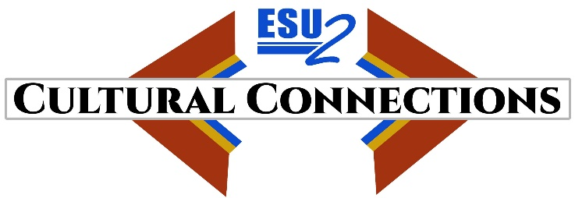

Cultural Connections Winter 2022 Update

Cultural Connections, Educational Service Unit 2’s US Dept. of Education’s Demonstration Grants for Indian Children and Youth Program’s Accessing Choices in Education grant is now in its second year and halfway through the first schoolyear. ESU 2, NICC (Nebraska Indian Community College), and our school district partners Bancroft-Rosalie, Homer, Lyons-Decatur, and Oakland-Craig, Pender, Emerson-Hubbard are implementing our plan to support culturally relevant student opportunities, supports, and educational choice for Native American students and their families.

Dr. Chris Stogdill, the former middle school principal at Blair Community School District, began working as our full time Cultural Connections coordinator on July 1, 2021. He is working closely with the schools, partners, and visits each of the sites.

Project highlights over the 1st semester of the 2021-22 school year include:
- Cultural Connections Service and Support Request Portal went live on September 1, 2021 and has received 40 requests for service. Categories of the requests include academic tutoring, mentoring, access to mental health services, transportation, Native language, dual credit assistance, after school programming, cultural trips and travel, and sports equipment assistance for items not provided by the school.
- Seven kick-off community meetings at the sites attended by 95 people.
- Continuing purchase of culturally relevant books and materials for the media center at each district—so far this school year we have spent over $10,000 on this effort.
- Supporting nine Bancroft-Rosalie students enrolled in enrolled in the Omaha Language class from Nebraska Indian Community College.
- Ongoing funding for two paraprofessional positions and one half-time counselor at Bancroft and two success coordinators and one behavior coach at Homer.
- Brought 10 Omaha Language students and two sponsors to the National Indian Education Conference in Omaha, October 2021.
- 24 Bancroft-Rosalie and 6 Lyons-Decatur students attended Hamilton on November 4 in Omaha.
- 4 students and 2 sponsors attended the Memorial March in Sioux City in November.
- Completed and distributed Cultural Connections/how-to-use-portal brochure January 2022.
- Created an infographic to help parents/guardians navigate the portal January 2022.
- 10 students and a sponsor attended the Joslyn Museum exhibit, “Faces from the Interior: The North American Portraits of Karl Bodner” in February 2022.
- Additional tutoring services are being offered at Pender, Homer, and Oakland.
- Planning has begun for pilot summer 2023 student trip to regional Indigenous person historical and cultural sites.

